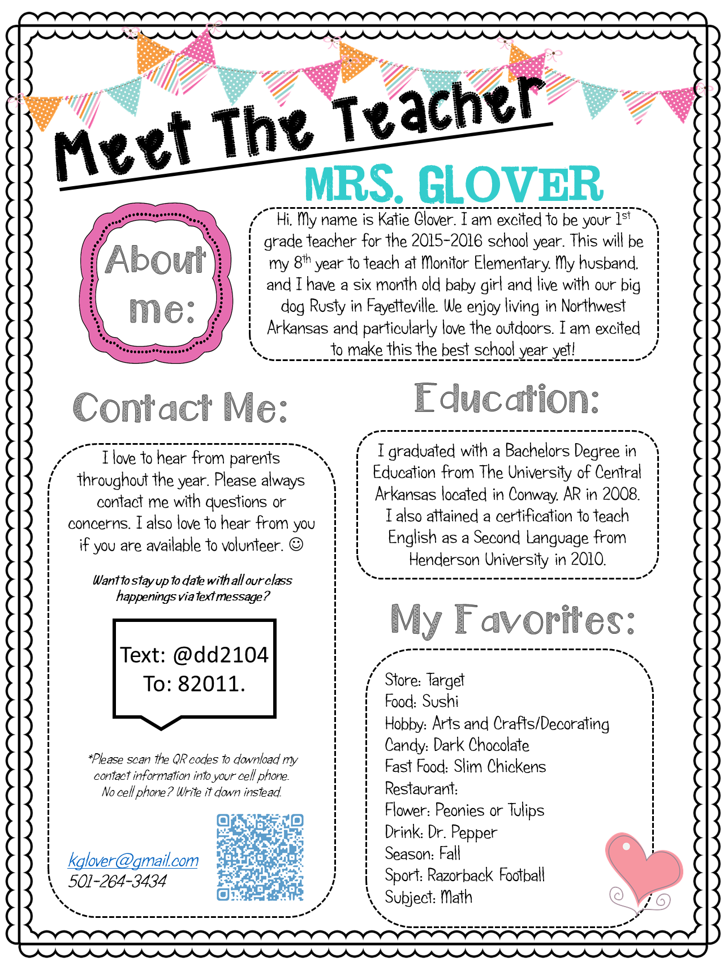

Hello, my name is **Mrs. Martin** and I am going to be your fifth grade teacher this upcoming school year. I am so excited to be a part of the Pine Run family with each one of you. Before coming to Pine Run, I began my career at Barclay for many years. Fun Fact: I’ve taught every grade level except 6th.

In the spirit of the beginnings of a new school year, I would like to ask you what your hope and dream is for this year. Please send me an email with a goal you have for yourself this year. You can include an academic goal, a social goal, or both. You can include any amount of detail you would like-any response will be greatly appreciated in helping me get to know you better. My personal hope and dream this year is that every student feels cared for and enjoys all that 5th grade has to offer. I can’t wait to hear from you. My email is [smartin@cbsd.org](mailto:smartin@cbsd.org) Enjoy the rest of your summer!

**Store:** Target

**Food:** pizza

**Hobby:** reading and taking walks, planning trips

**Candy:** Swedish Fish

**Fast Food:** Chick-fil-A

**Flower:** daisy

**Season:** summer

**Sport:** soccer

**Subject:** writing

**What are your favorites?**

Maintaining parent-teacher communication throughout the school year is key to student success.

The best way to reach me is through my email at [smartin@cbsd.org](mailto:smartin@cbsd.org).



My phone number is 267-893-4450 ext. 4469.

Fifth Grade is an exciting year, and I cannot wait to explore, learn, and have fun together.

Education is very important to me. I graduated with a bachelor’s degree from Penn State University. In 2009, I earned my master’s degree in Elementary Education. After that, I became a writing fellow from the Pennsylvania Writing Institute.